APPENDIX A

Local Government Association Submission. The Lyons Housing Review.

The LGA is pleased to submit written evidence to the Lyons Housing Review. This is initial evidence. Our work on the issues the Commission is considering is ongoing and we will be happy to offer further evidence as it progresses.

Councils share the Commission’s ambition of delivering a sharp increase in the delivery of housing quickly. Building 200,000 housing units or more per annum is achievable only if councils play a full part in delivery including by building on their own account. The private sector cannot and will not alone deliver on the scale required. It has averaged 130,000 completions a year over the last 40 years.

Planning is not the major barrier to achieving this aim. Our analysis shows that the volume of housing completions mirrors economic cycles rather than planning reforms and is related to the capacity of the development industry, its access to finance and buyers’ access to mortgage finance. No planning reform of the last forty years has been associated with a significant change in the rate of private sector house building. On the contrary, councils’ experience and our own discussions with developers suggest that certainty in planning policy is crucial to secure developer confidence to invest in new housing development.

The outstanding volume of unimplemented planning permissions, currently at over half a million, suggests that, at the national level and in the short to medium term, land supply is not the crucial problem that is holding up housing development. More locally, there are many powerful examples of councils using their leadership position and legal powers creatively to assemble sites and almost all are bringing underutilised public land on-stream. Councils’ day-to-day experience shows that effective partnership working, especially through pre-application discussions, and simple transparent process – for example around statutory consultees and conditions – pay dividends in speeding up delivery and building developer confidence.

But – absent of a rescaling of the house building sector’s collective balance sheet – none of these improvements has much prospect of lifting the private sector’s likely capacity beyond a range of 150,000-200,000 units a year. A lot of work has been done on attracting extra institutional investment into housing. It is important to be realistic about the limits on the ability of housing to deliver what investors are looking for. The Housing Association sector is also capacity constrained, the more so given the degree of financial gearing it is currently under and the revenue risks presented by future constraint of the housing benefit bill. Our latest research shows that 45 councils estimate they would be able to build over 8,000 houses in total over the next five years on their own account. As an illustration if we assume that this delivery rate was representative of all stock holding councils they could deliver approximately 28,000 homes over the same period. This would be a significant increase in current build rates. Councils’ potential is limited by the Treasury set Housing Revenue Account borrowing caps. A lifting of the caps, the same research shows, could double that extra building over the same time period.

After a long recession in the industry, labour and suppliers have been lost. Councils through their build programmes can stimulate the local economy by using local suppliers and offering apprenticeship schemes as part of contracts.

As the Commission recognises, delivering the housing we need will require councils to work together to deliver across geographical and organisational boundaries. We set out in this submission a series of specific proposals to deliver a workable Right to Grow.

Finally, new settlements have the potential to deliver a game-changing uplift in housing numbers. Development corporations with appropriate planning powers and democratic accountability provide a model for delivering large scale housing development through garden cities and new towns. But long experience says that such settlements must be adequately supported with physical and social infrastructure to succeed.

Planning and housing growth.
It’s easy to blame planning for not delivering the numbers of houses this country needs - but in reality these complaints duck the big issue. The private sector has only built 200,000 homes a year twice since the Second World War, most recently in 1968. Over the last 40 years, the private sector has built an average of 130,000 homes a year. And the evidence shows that private house building numbers are driven by the state of the economy, house prices and the access homebuyers and house builders have to finance. The planning system has experienced five major reforms since the original Town and County Planning Act: the chart below shows how little effect that has had on house building.

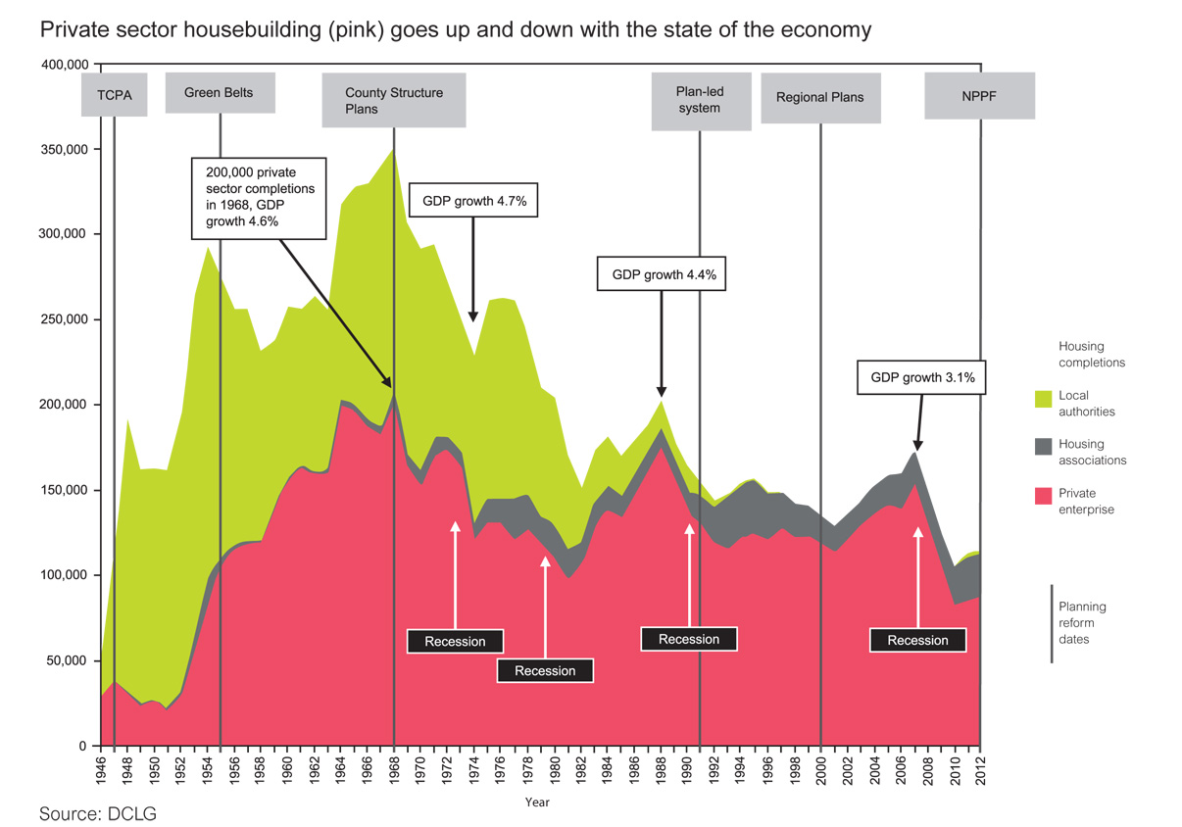

A plan led system is the most effective way of ensuring that land with community support for housing is made available and providing long term certainty to encourage investment in new build housing with the necessary infrastructure.

The current system is bedding in well and large scale reform of the planning system should be avoided. Over 70% of councils have published local plans which provide certainty to investors.

Councils approve almost 9 out of 10 planning applications received but many of these permissions remain outstanding. In 2013 there were an estimated 507,000 units with planning permission that had not yet been built out. Councils need to be able to create stronger incentives for developers to build out sites. This is likely to require a range of powers which might include:

- Financial penalties for developers where they have sought and acquired a planning permission- using up the land supply in the planning system – but then allowed it to expire. This should include a percentage increase in the Community Infrastructure Levy liability which increases every year the development remains un-commenced after the first planning permission has expired. The powers should also enable Councils to charge an amount equal to the estimated annual council tax take from that development every year from the point that the original permission expires. Safeguards and exemptions would need to be put in place to ensure that individuals and small developers would not be disproportionately penalised by this measure and that developers were not dissuaded from bring forward planning applications.

- Stronger compulsory purchase powers where permissions have expired and development has not commenced. This should include an exemption from the requirement to purchase the land at the current market value and pay compensation to the land owner. Instead local authorities should be enabled to compulsorily purchase land at its existing use value. This proposal has parallels with the use of compulsory purchase powers in Europe.

- Levies on land that is considered suitable and desirable for development by virtue of its inclusion in the local plan, but that has not been built out, may also provide an option to encourage swifter housing development. Kate Barker investigated this issue in her 2004 review of housing supply. As above safeguards and exemptions would need to be put in place to guard against unintended consequences.

All powers should be enabling and should allow for exemptions in exceptional circumstances. For example in cases where developers bought land as part of a wider regeneration scheme which has itself stalled or been withdrawn through no fault of the developer.

Securing an increase in house building.
There are opportunities for all Housing Authorities to deliver, support, attract and underpin housing investment.

For all authorities, using public land effectively can increase the viability of development and attract private investment in housing. 98% of respondents to a recent LGA survey plan to use their own land to bring forward housing development in the next five years. A number of councils have made strides to pool land assets with central government departments and agencies and this work should be extended. This should include the transfer of land to councils in order to allow simpler decision making so that development can be brought forward more quickly.
The Manchester City Deal establishes a Housing Investment Board, with Government, to manage a development strategy and effectively use national funds, local investment and public assets to boost housing development. A senior HCA representative will sit on the board and integrate HCA schemes and assets as part of this joint approach. This will maximise the potential to deliver new homes using the ‘build now-pay later’ principle, leading to an estimated 5,000 – 7,000 new homes by 2017.

Over 80% of respondents to a recent LGA survey indicated that they were planning to work in partnership to deliver new housing in the next five years. Twenty four councils indicated that they planned to deliver over 7,000 homes in partnership over the next five years. Using these figures we can estimate that all councils in England plan to deliver 77,000 new homes in partnership over the next 5 years. The LGA’s recently published case study guide provides examples of innovative approaches and is attached to this submission.
The Gateshead Regeneration Partnership between Gateshead Council and Evolution Gateshead will deliver 2,400 homes over the next 15 years. The Council is using its land assets to secure private finance through a Local Asset Based Vehicle. Sites are being ‘bundled’ together in groups of three or so where the sites with a positive value will cross-subsidise those with a negative value and thereby ensure development across the bundle.

The development will create local employment and economic opportunities: 25% of employees working on the project will be from Gateshead and 25% of the value of supply chain opportunities will go to Gateshead businesses.

Councils are also exploring alternative sources of investment for housing. For example:
- The LGA is considering the establishment of a Municipal Bonds Agency. Borrowing through the agency would be within the prudential code and would fund productive capital investment. Almost 40 authorities have indicated interest and £3.9 billion potential new borrowing and refinancing has been identified over the next 3 years. The LGA will be taking a decision on whether to progress to establish the agency in Spring 2014.

- A number of councils are investigating the potential to access Local Government Pension Scheme Fund investment (LGPS) for housing. The potential to scale up the investment provided by LGPS funds is limited. This is because the investments are not often enough packaged in a way that that fit with the LGPS funds’ investment strategy and governance arrangements. As a result the sector often finds it difficult to participate in funding exercises to finance economic growth projects and often turns to infrastructure opportunities abroad.

We estimate that almost 90% of councils with their own housing stock are planning to directly fund the building of new housing through the Housing Revenue Account. Respondents to a recent LGA survey were asked if their authority was planning to directly fund the building of any new housing in the next five years. The 45 councils who responded projected build levels of over 8,000 units over this period. As an illustration, if all stock owning councils built at this rate they would deliver approximately 28,000 new homes solely through the HRA over the next five years¹⁰. This would represent a significant scaling up in recent council house building levels.

Exhausting the routes above will deliver an uplift in housing development. It will not however be sufficient to close the shortfall in provision. We need to free both local authorities and housing associations to build to their full capacity. Councils estimate that they could build nearly three times as many homes directly through the HRA if the debt cap was removed and they could borrow up to prudential limits. The LGA recommends lifting the HRA borrowing cap to release this latent capacity to deliver more housing quickly and at scale.

Strategic planning for housing

The current legal and policy framework puts in place requirements to support ongoing engagement and cooperation to plan strategically for housing need.

- The Duty to Cooperate places a legal duty on local authorities to work together to plan strategically for their area; failing to meet this duty results in a plan being found unsound at examination. The requirement to cooperate is ongoing.

- The National Planning Policy Framework (NPPF) establishes a requirement on local authorities to ensure that their plan is up to date and deliverable. Failure to comply leaves the authority at risk of challenge over its planning decisions.

Whilst joint working and cooperation is rarely straightforward it is the most effective approach to secure community acceptance through locally democratic decision making whilst ensuring planning takes place at an appropriate spatial level. The Right to Grow should build on and strengthen this approach whilst maintaining democratic decision making at its heart.

We would suggest the following amendments to strengthen the existing process.
- Establishing a locally appropriate spatial area to plan strategically: Local Enterprise Partnerships (LEPs), where they represent the natural groupings of councils with agreed growth priorities could provide an appropriate spatial area over which to plan strategically for housing. Local areas should have the flexibility to review their current LEP boundaries to ensure that they are fit for purpose. The LGA will be undertaking further work on this issue and would be happy to share this with the Review at an appropriate point.

- Planning decisions would still be made by the individual local authorities working in partnership across the LEP area. We do not suggest that LEPs become involved in planning decisions: our point is that sub regional partnerships where they reflect natural groupings of councils will often be the appropriate area to undertake strategic planning.

- In those instances where strategic planning across boundaries breaks down we propose that political and technical support and peer challenge is put in place to unblock barriers and work with authorities to negotiate a way forward. This work is most appropriately led by the local government sector. Sector led support should always be the default first response. As is the case in other service areas in rare cases of failure across a service (s) the government retains a backstop power to intervene.

The proposed process is set out below
Councils cooperate to meet housing need

Submission of draft local plan for inspection

Current legal requirement to engage constructively, actively and on an ongoing basis. Localism Act 2011.

Tested at examination by PINS
FAIL
PASS

New: Sector led mediation service.
Current policy requirement in the . NPPF
Positively prepared, justified, effective and in line with national policy. PINS test whether the plan is deliverable and demonstrates effective joint working.

FAIL
PASS
Tested at examination by PINS

Advice: Sector led technical advice
Sound Plan

PASS

Policy requirement: The NPPF requires councils to keep their plan up to date. This ensures ongoing cooperation, monitoring and updates.

Delivering large scale housing development through Garden Cities and New Towns

Supporting large scale housing development through the development of new towns and garden cities provides an opportunity to make strides in the delivery of housing in a coordinated and cohesive way. It also provides a route to maximise the use of brownfield land. Sustainable urban extensions also provide a route to expand current infrastructure provision (and therefore could offer development at lower infrastructure costs) and boost the growth prospects of towns and cities quickly.

Engagement with the local community and securing acceptance for the need for development will be crucial. Councillors responding to an LGA survey in 2012 identified resident opposition as the most significant barrier to housing development and highlighted the impact of infrastructure provision in alleviating local concerns. With this in mind, identification of sites for large scale development should not be imposed centrally but should be drive by authorities or groups of authorities.

The London Legacy Development Corporation was established as a Mayoral Development Corporation using powers in the Localism Act 2011 which conferred a range of planning, land acquisition and infrastructure powers on the corporation. The powers in the Localism Act 2011 should be extended to enable a local authority or groups of local authorities to establish such a corporation across or within their areas for the purpose of large scale development.

Large scale housing development must be owned locally and democratically accountable. The London Legacy Development Corporation Board includes elected representation from each local authority that the Development Corporation covers. The Corporation is accountable to the Mayor of London. The same principle should be applied to the development of new towns and garden cities which should be owned and led by the relevant local authorities. The Corporation should be directly accountable to residents through ownership by the relevant local authorities of which it is comprised.

Adequate long term investment in physical and social infrastructure is critical to the success of the new community. CLG’s review of transferrable lessons from the New Towns programme highlights that as infrastructure had to be installed in advance of population growth and demand, and thus before the increase in local council tax that the construction required significant finance over a considerable period of time. Councils do not have the resources to fund the additional costs associated with large scale development of this kind. CIL contributions will also not be sufficient to close the infrastructure gap for the development. Any attempt to pass on the full costs of infrastructure to private sector developers is likely to render the development unviable and act as a significant disincentive to invest. This issue has been raised as part of an analysis of schemes in the South and South East of England by property consultants GVA . Government will therefore need to provide a significant capital funding allocation to underpin new towns and garden cities. Failure to provide this leaves projects open to the risk of long running disputes over infrastructure costs.

Land assembly will also be a key challenge early on. As referenced earlier in this submission we would like to see broader Compulsory Purchase powers to enable councils to acquire land for major development at its existing use value. This would support and facilitate the development, infrastructure and community facilities using the uplift in land value capture.

http://www.publications.parliament.uk/pa/cm201314/cmhansrd/cm131024/halltext/131024h0002.htm
LGA (2014). Housing self-financing survey: a survey of councils and ALMOs http://www.local.gov.uk/research-housing These grossed figures are based on data provided for directly funded housing by 45 councils (27 per cent of 164 councils and ALMOs with housing stock in England). They are calculated using the assumption that those answering would be representative of non-responding councils. Whilst in practice this level of response rate means there is likely to be some variation between responding and non-responding councils, this gives a helpful indication of what the current position might be and is based on the best evidence currently available.
Councils delivered 1,360 homes in 2012/13, CLG statistics, table 209
Planning and Growth – the facts - February 2014
https://www.gov.uk/government/statistical-data-sets/live-tables-on-planning-application-statistics
http://www.publications.parliament.uk/pa/cm201314/cmhansrd/cm131024/halltext/131024h0002.htm
For example the Netherlands – local authorities have traditionally purchased land at existing use value, provided infrastructure and services, and sold it to developers at a price that at least recovered costs
http://webarchive.nationalarchives.gov.uk/+/http:/www.hm-treasury.gov.uk/barker_review_of_housing_supply_recommendations.htm
LGA (2014). Housing self-financing survey: a survey of councils and ALMOs http://www.local.gov.uk/research-housing
LGA (2014). Housing self-financing survey: a survey of councils and ALMOs http://www.local.gov.uk/research-housing
LGA (2014). Housing self-financing survey: a survey of councils and ALMOs http://www.local.gov.uk/research-housing These grossed figures are based on data provided by 24 councils (15 per cent of 164 councils and ALMOS with housing stock in England) for homes built in partnership and 45 councils (27 per cent) for homes built solely through the HRA. They are calculated using the assumption that those answering would be representative of non-responding councils. Whilst in practice this level of response rate means there is likely to be some variation between responding and non-responding councils, this gives a helpful indication of what the current position might be and is based on the best evidence currently available.
LGA (2014). Housing self-financing survey: a survey of councils and ALMOs http://www.local.gov.uk/research-housing
Councils delivered 1,360 homes in 2012/13, CLG statistics, table 209
LGA (2014). Housing self-financing survey: a survey of councils and ALMOs http://www.local.gov.uk/research-housing 27 Councils estimated that they could build an additional 7350 homes if there was no debt cap in place and they could borrow up to prudential limits Based on these findings we estimate that councils could build an additional 48,000 homes. These figures are calculated using the assumption that those answering would be representative of non-responding councils. Whilst in practice this level of response rate means there is likely to be some variation between responding and non-responding councils, this gives a helpful indication of what the current position might be and is based on the best evidence currently available
http://www.local.gov.uk/c/document_library/get_file?uuid=39455ab7-9fea-4892-9021-d3e88d0e3b35&groupId=10180
http://www.futurecommunities.net/files/images/Transferable_lessons_from_new_towns_0.pdf
Unlocking Garden Cities, GVA, 2013

